**Geopolymer-zeolite composite materials for carbon capture applications: adsorption tests and modelling of thermal effects**

M. Boscherini1,2*, F. Miccio2, E. Papa2, V. Medri2, E. Landi2, F. Doghieri1, M. Minelli1

*1 Department of Civil, Chemical, Environmental and Materials Engineering (DICAM), Alma Mater Studiorum, University of Bologna, via Terracini 28, 40136 Bologna, Italy*

*2 Institute of Science and Technology for Ceramics (ISTEC), National Research Council of Italy (CNR) , via Granarolo 64, 48018 Faenza, Italy*

*\*mattia.boscherini3@unibo.it*

**1.Introduction**

As the need for achieving carbon neutrality in industrial processes and energy production increases following rising worries of the scientific community towards the effects of climate change, researchers attention has been focused on finding competitive ways to obtain carbon dioxide sequestration from gaseous currents such as flue gas. Carbon capture is considered an essential strategy to contain the increase of global average temperature below the threshold of 1.5°C estimated by the Intergovernmental Panel on Climate Change to cause irreversible climate changes and environmental damage [1, 2]. Nowadays, the most common sequestration technology is the ammine absorption, but as this process presents limitations due to high costs, toxicity and volatility of amines other methodologies are being evaluated. In particular, adsorption processes offer a very promising solution, both clean and reliable, and are therefore becoming of increasing interest thanks also to their potential for retrofit application to existing industrial plants [3]. with research focused both on sorbent material development and process optimization. Different materials have been proposed for CO2 sorption, from conventional sorbents such as active carbon to Metal-Organic Frameworks, zeolites and supported amines [4]. A good adsorbent material should possess an high adsorption capacity for CO2 and large selectivity towards other gases, while also being thermally stable and possessing good mechanical resistance in handling and loading operations [5].

Adsorption is usually operated as a semi-continuous process: the CO2 containing gaseous stream is fed to a sorbent bed until the breakthrough point is reached, then the feed is switched to a second bed while the first one undergoes regeneration. Two different approaches can be applied to regenerate the sorbent bed: either increasing the temperature, in a temperature swing adsorption (TSA), or decreasing the pressure, obtaining a Pressure Swing adsorption (PSA). Breakthrough time can be defined as the time when the concentration of the key component, CO2 for carbon capture applications, reaches a preset threshold value (e.g. 5 or 10% of the inlet value), which can be optimized in order to maximize process efficiency. While fixed beds operate semi-continuously, continuous operation may be achieved by fluidized beds through the circulation of the sorbent from the adsorption to the regeneration bed [6].

This work presents the study of a CO2 adsorption process in a composite geopolymer/zeolite material, with the purpose of evaluating material performance in dynamic conditions. Previous studies in pressure decay adsorption regime reported that this material presents a high affinity for CO2 adsorption, thanks to a synergic effect between the zeolite and the geopolymeric matrix [7, 8]. Following these findings, cyclic adsorption/desorption breakthrough tests were therefore employed to investigate material performance in transient conditions. Particular focus was put on monitoring the temperature profile of the experimental sorption column, to inspect the strong thermal effects associated with the adsorption process and evaluate their potential influence on adsorption capacity and kinetics [9]. Adsorption/desorption cycles were examined under different thermal regimes, in order to compare the performance of PSA, without external temperature control, to TSA performed in a heating regime at constant temperature in a range between 50-80°C. Heating regimes are expected to improve material regeneration by favoring the endothermic desorption of carbon dioxide.

Numerical models are a useful tool for improving knowledge of processes, and in particular for process optimization. A model for the description of the adsorption process was developed and tested based on the obtained experimental data. The model accounts for both mass and energy transport in the sorbent bed, modelling concentration and temperature profiles both for the gas phase and the sorbent bed. The was validated using the collected experimental data, and was then employed to predict the behavior of the sorbent in different operating conditions, such as different feed concentration and temperature. Useful indications on the internal profiles of temperature and concentration in the sorption bed are also be obtained, in particular also predicting the effects of a possible scale up of the process.

**2. Methods**

**2.1-Sorbent preparation and characterization**

The sorbent is a composite of zeolite 13X and Na based geopolymer having specific surface area of 221 m2/g. The geopolymer-zeolite composite has been fabricated using formulations and procedures reported on previous works [7, 8]: geopolymer with theoretical Si:Al molar ratio equal to 1.2 was prepared by mechanically mixing metakaolin M1200S (Imerys) with a sodium hydroxide solution (10 M), and adding 27% wt. of Na13X zeolite powder, Na86[(AlO2)86(SiO2)106]⋅H2O (Sigma-Aldrich, average particle size = 2 μm, specific surface area = 791 m2/g and pore volume = 301 mm3/g) to the slurry. The material was then cured for 24 h at 80 ◦C in closed vessels and for other 24 h at 80 ◦C in open vessels. After consolidation, the obtained monoliths were crashed into granules and sieved in the ranges 400–630 μm.

**2.2-Dynamic adsorption tests**

A glass column (diameter 25.7 mm and height 200 mm) was filled by sorbent granules (400-630 μm size) forming a fixed bed. Two electronic mass-flow controllers (Brooks Instruments mod. 5850S) and a quick switching valve on the CO2 line were used to provide the feed gas mixture of CO2 and N2, obtained from bottles of pure N2 and CO2.The valve allowed to switch between adsorption and desorption phases by intercepting the CO2 flux before the column. Heating was provided through an external electric coil, and the column insulated with multiple layers of Teflon tape to avoid heat dispersion. A K-type thermocouple is inserted in the outlet section of the column to measure internal temperature. Outlet concentration of the gas is monitored by a multicomponent gas analyser (Testo 350). Both complete adsorption tests (bed is brought to saturation), and cyclic tests (adsorption step interrupted at breakthrough point, set at 5% of inlet CO2) were performed. By integrating the mass balances for N2 and CO2, the amount of adsorbed CO2 can be calculated from the outlet concentration profiled over time (N2 adsorption is neglected):

 (1)

in which n ̇ is the molar flowrate, $y_{CO_{2}}^{in}$ and $y_{CO_{2}}^{out}$ are respectively the CO2 inlet and outlet molar fractions of the gas flow, ms is the mass of the sorbent, and t0 and tads are the initial time and the duration of the adsorption test, respectively. Sorption apparatus detailed description can be found in a previous work [10].

**2.3-Model description**

The model was coded in FORTRAN and is based on plug flow assumption for description of the sorbet bed (1-D model). Mass and energy balances are solved on the basis of continuum thermomechanics. The Peng-Robinson equation of state was chosen to describe the gas phase, while CO2 adsorption in the solid sorbent is represented through the Sips equation in the sorbent phases. The 7 parameters employed in Sips equation were retrieved from best fit of experimental adsorption isotherms obtained from pressure decay at different temperatures). Only CO2 is modelled to adsorb and sorption kinetics are modelled according to a linear driving force (LDF) approach [11]. The differential equations system solved includes mass, species, energy and momentum balances in the domain (0≤t; 0≤z≤L), where L is reactor length. A time implicit volume discretization method is used for calculation: a grid of 100 equally spaced nodes in the axial direction (z) and a constant time-step are used. Three nested loop iterations are conducted for pressure, concentration and temperature profiles. The complete set of equations solved by the model is the following:

 (2)

In these equations, yCO2 is the fraction of active component in the gas phase, n is the molar flux density of the gas in the axial direction and qCO2 is the concentration of active component adsorbed in the solid (q* is the corresponding CO2 capacity), c is the gas phase concentration (Peng-Robinson). Cg is the gaseous phase heat capacity linearly dependent on temperature and composition, while  is the (constant) viscosity of the gas phase. The axial dispersion coefficients for mass transfer (D) and heat transfer (kg) are calculated as functions of sorbent particle diameter, total void fraction, molar flux density, gas concentration and molecular diffusivity. Rp is the radius of the column, while εt and εb are respectively its total and bed void fractions. The following boundary conditions are used for integration:

 (3)

The model is set to calculate the initial CO2 content in the bed starting from the set regeneration conditions*.*

**3. Results and discussion**

The comparison of results obtained indicates that in breakthrough mode about 50% of the CO2 amount sequestered in complete adsorption tests can be sequestered, while notably lessening required times (11 vs. 140 min). Appreciable thermal effects are observed in complete tests during adsorption and desorption steps, with a maximum of temperature during the exothermic adsorption and a minimum during the endothermic desorption. The increase of temperature in adsorption was observed to be larger than 10 °C, with peak observed shortly after the BT time, coinciding with maximum adsorption. Temperature then slowly decreases with adsorption rate as saturation of the bed is reached. Temperature decrease during desorption is less marked, due to slower kinetics. Higher CO2 concentration in the feed leads to higher temperature peaks during adsorption, and interestingly this large temperature increase depresses adsorption more significantly than at lower values, so the resulting capacity at the BT deviates more appreciably from the that obtained in complete adsorption tests.

Fig. 1 and 2 shows adsorption cycles performed in different heating regimes, showing the effects of heating during desorption segment carried out up to the breakthrough point. Orange line represents feed concentration. As can be seen, desorption is much faster when heat is applied, achieving faster and better material regeneration.

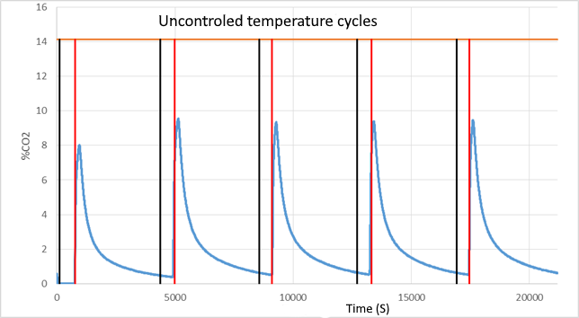

**Figure 1.** Adsorption/desorption cycles concentration profiles without external temperature control.

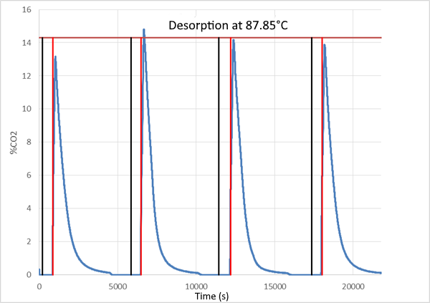

**Figure 2.** Adsorption/desorption cycles with external heating applied: desorption at constant temperature.

**4. Conclusions**

Experimental results demonstrate that a combined pressure-swing and temperature-swing strategy is the optimal solution to process optimization, leading to shortened sorbent regeneration time. A regeneration temperature above 80°C was found to be necessary to restore material sorption capacity along consecutive sorption/desorption cycles.

The model has been proven to represent well the experimental results obtained at different CO2 feed concentrations, in terms of both concentration and temperature profiles in column outflow gas and in sorbent bed, and after validation has also been first tested to predict some effects of process scale up on sorption performance.

**References**

[1] IPCC, 2014: Climate Change 2014: Synthesis Report. Contribution of Working Groups I, II and III to the Fifth Assessment Report of the Intergovernmental Panel on Climate Change [Core Writing Team, R.K. Pachauri and L.A. Meyer (eds.)]. IPCC, Geneva, Switzerland, 151 pp.

[2] European Commission; COMMUNICATION FROM THE COMMISSION TO THE EUROPEAN PARLIAMENT, THE EUROPEAN COUNCIL, THE COUNCIL, THE EUROPEAN ECONOMIC AND SOCIAL COMMITTEE, THE COMMITTEE OF THE REGIONS AND THE EUROPEAN INVESTMENT BANK A Clean Planet for all A European strategic long-term vision for a prosperous, modern, competitive and climate neutral economy; COM/2018/773 final; Bruxelles

[3] M. Younas, M. Sohail, L.K. Leong, M.J. Bashir, S. Sumathi, Feasibility of CO2 adsorption by solid adsorbents: a review on low-temperature systems, Int. J. Environ. Sci. Technol. 13 (2016) 1839–1860.

[4] Junya Wang, Liang Huang, Ruoyan Yang, Zhang Zhang, Jingwen Wu, Yanshan Gao, Qiang Wang, Dermot O'Hare and Ziyi Zhong; Recent advances in solid sorbents for CO2 capture and new development trends; Energy Environ. Sci., 2014, 7,3478

[5] R. Ben-Mansour, M.A. Habib, O.E. Bamidele, M. Basha, N.A.A. Qasem, A. Peedikakkal, T. Laoui, M. Ali, Carbon capture by physical adsorption: Materials, experimental investigations and numerical modeling and simulations – a review, Appl. Energy 161 (2016) 225–255.

[6] Gupta K.N., Kumar R., Kinetic modeling and optimization of fraction of bed utilized for the gaseous phase removal of toluene in fixed bed adsorption column: response surface methodology, 2020, Separation Science and Technology 55, 1062–1077

[7] Minelli M., Papa E., Medri V., Miccio F., Benito P., Doghieri F., Landi E., 2018, Characterization of novel geopolymer – zeolite composites as solid adsorbents for CO2 capture, Chemical Engineering Journal 341, 505–515.

[8] Minelli M., Medri V., Papa E., Miccio F., Landi E., Doghieri F., 2016, Geopolymers as solid adsorbent for CO2 capture, Chemical Engineering and Science 148, 267–274.

[9] Xiao J., Peng Y., Bénard P., Chahine R, 2016, Thermal effects on breakthrough curves of pressure swing adsorption for hydrogen purification, International Journal of Hydrogen Energy 41, 8236-8245.

[10] Boscherini M., Miccio F., Papa E., Medri V., Landi E., Doghieri F., Minelli M, 2021, The relevance of thermal effects during CO2 adsorption and regeneration in a geopolymer-zeolite composite: Experimental and modelling insights, Chemical Engineering Journal 408, 127315.

[11] Gholami M., Talaie M.R., 2010, Investigation of simplifying assumptions in mathematical modeling of natural gas dehydration using adsorption process and introduction of a new accurate LDF model, Industrial Engineering Chemistry Resources 49, 838–846.